Alliance for future-oriented power distribution and intelligent drive technology
Lenze and Rittal sign technology partnership
Herborn, 2025-5-15

One of the most important objectives for companies in the field of machine and plant engineering today is to realise all available optimisation potential. Lenze and Rittal have signed a technology partnership and will be working together to shape the future of power distribution and drive technology. The combination of RiLineX, as the new standard platform for busbar systems, and Lenze’s market-leading compact inverters provides the basis.

Machine engineering faces ever-growing demands. Complex drive solutions must be flexible, reliable and increasingly compact. Furthermore, skill shortages and cost pressures necessitate a new level of efficiency in planning and design, assembly and commissioning of equipment and systems. This is where Lenze and Rittal intend to bring joint leverage to bear as technology partners. “Lenze sets the pace in the field of automation. By integrating electromechanical, electronic and software expertise they demonstrate an understanding of the customer’s processes far beyond the functions of individual components. That aligns perfectly with Rittal’s approach and makes the company an excellent technology partner within the RiLineX ecosystem,” says Ulrich Engenhardt, Chief Business Units Officer at Rittal. “With the system platform RiLineX, Rittal is defining new standards for power distribution in the enclosure. Through the incorporation of Lenze inverters, we can now extend the benefits to drive technologies and create more compact solutions for our customers,” adds Dr. Marc Wucherer, CEO of Lenze SE.

Double savings of space and time
One practical example of the synergy effects for users is the i550 cabinet frequency converter from Lenze. This compact inverter can be operated across an unusually broad temperature range from -30 to +60°C and offers open interfaces to all common control systems, with scalable functionality for conveyor drives, traction drives, winding and hoist drives, extruders, packaging machines and industrial air-conditioning systems. “The Lenze i550 cabinet is the most compact frequency inverter in the world in its class. This key plus point is further enhanced in combination with RiLineX,” says Christian Eberhard, Senior Vice President Sales EMEA Central at Lenze. “The platform allows for even simpler, space-saving installation.”

What is the secret? The usual place of installation on the mounting plate is freed up for other components, because the inverter and its fusing are now mounted via a single adapter on the RiLineX board according to the “click-&-work” principle – at the same time guaranteeing the highest possible packing density. The slim design of the frequency inverter supports seamless inline mounting on the board, which itself allows unrestricted top mounting. Cable connections and the associated risk of mistakes are thus a thing of the past. For customers this means that after 30 per cent time savings in engineering and up to 75 per cent savings in assembly with RiLineX, inverter installation maintains the high speed and brings significant space benefits in the enclosure. The wi-fi data connection to the frequency converter also accelerates commissioning.

“It’s not without reason that our configuration software RiPower first proposes components from our technology partner ecosystem. In this way, we offer our customers immediate access to tested components like the Lenze inverters, which are especially suitable for future-proof machine engineering and supply comprehensive data for engineering with Eplan,” says Raphael Görner, Executive Vice President Energy & Power Solutions at Rittal.

Data quality for faster processes
High data quality is a prerequisite for efficient planning and designing and configuration. Both partners have here adopted a similar approach. One of the strengths of Rittal RiPower is the close integration with Eplan software. As an Eplan Technology Partner, Lenze also makes use of the high-quality data for its customers. The Eplan Data Portal with its more than four million items of article data, for example, is similarly a data source for Lenze’s EASY Product Finder (EPF), an online tool to simplify the selection, configuration and ordering of Lenze products for the customer. In addition to the configured product, the system generates a complete set of Eplan data including wiring lists, enclosure add-ons and manufacturing documentation from Eplan Pro Panel. Lenze customers can download all manufacturing data in Eplan format at the press of a button.
The same data are accessed by the EASY System Designer, Lenze’s web-based engineering tool for drive configuration and the overall planning of machine solutions ‒ for simple system design and reduced personnel requirements while nevertheless shortening development times and maximising quality.

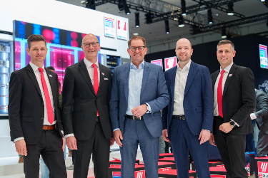
Image 1  New partnership for the future of power distribution and drive technology: Philipp Guth, CTO Rittal, Ulrich Engenhardt, CBO Rittal, Dr. Marc Wucherer, CEO Lenze SE, Christian Eberhard, Senior Vice President Sales EMEA Central at Lenze, and Raphael Görner, Executive Vice President Energy & Power Solutions at Rittal.  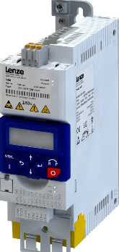  Image 2  The i550 cabinet from Lenze is the most compact frequency inverter on the market in its class. Mounting on RiLineX frees up further installation space. |  | 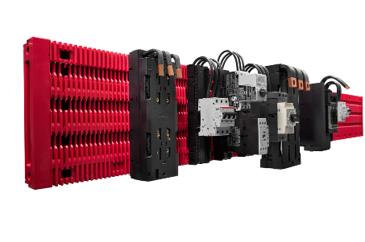  Image 3  RiLineX reduces assembly time by up to 75%. Rittal already initiated an ecosystem with technology partners before the sales launch.
May be reproduced free of charge. Please name Rittal GmbH & Co. KG as the source.
s
Rittal

Rittal is a leading global supplier of enclosure systems, automation and infrastructure with its industrial, IT, energy and power, cooling and service units. Rittal products and solutions are used in over 90% of global industries – standardised, customised, and always of the very best quality. Our approach and methodology: Rittal, Rittal Software Systems (Eplan, Cideon) and Rittal Automation Systems (RAS, Ehrt, Alfra) combine their hardware and software expertise to streamline, optimise and digitalise processes across the entire value chain for our customers including their IT infrastructure – from control and switchgear construction, machine building to factory operators or the energy sector.
Our delivery promise: Rittal standard products are delivered in Germany within 24 hours, and within 48 hours throughout Europe.

Customer focus
Improving efficiency and increasing productivity through automation and digitalisation is one of the biggest challenges for our customers. This requires in-depth knowledge and expertise, the combination of hardware and software, and cross-sector networking. We are convinced that creating and connecting data rooms is crucial to the success of industrial transformation. And that is exactly our speciality and field of competence. Eplan and Rittal are driving the development of the digital automation twin, making data accessible and useable in operations as well. Cideon is improving data consistency in the digital product twin context with its CAD/CAM, PDM/PLM and product configuration expertise.

Sustainability
Environmental and climate protection, social commitment and ethical corporate management are a given for Rittal. We take our responsibility for a sustainable future seriously. Our approach to resource management and conservation involves continuous improvement of our own production processes and ensuring that our products have the lowest possible Product Carbon Footprint. Our solutions support our customers in achieving their own climate targets.

Family business and global player
Founded in 1961, Rittal is the largest company in the owner-operated Friedhelm Loh Group. The group operates worldwide, with 13 production sites and 95 international subsidiaries. It has 12,600 employees and posted revenues of 3.1 billion euros in fiscal 2024. In 2023, the Friedhelm Loh Group was presented with the “Best Place to Learn” and “Employer of the Future” awards. In 2024, Rittal was awarded the Top 100 Seal as one of Germany’s most innovative medium-sized companies for the third time in a row.

Further information can be found at www.rittal.com and www.friedhelm-loh-group.de

Corporate Communications
Dr. Carola Hilbrand Rittal GmbH & Co. KG
Corporate & Brand Communications Auf dem Stützelberg
Phone: +49 (0)2772/505-2527 35745 Herborn, Germany
hilbrand.c@rittal.de www.rittal.com

Lenze

Lenze is a leading automation specialist and focuses on designing efficient and sustainable processes for production and material flow. For over 75 years, the company has been a pacesetter in automation and a strong partner at the side of its customers from the machine and plant manufacturing industry. With the help of a triad consisting of electrical engineering, software and a platform strategy, Lenze supports its customers in digitization and helps them to cut costs, optimize the utilization and lifecycle of machine systems and reduce their energy consumption.
The Lenze Group, headquartered in Aerzen, employs more than 3,600 people globally and is represented in 45 countries. Group-wide, the company generated sales of € 828.0 million in the 2023/2024 financial year.
www.Lenze.com

Press contacts of Lenze Group:
Corporate Communications
Head of Corporate Communications
Cornelia Müller
Hans-Lenze-Straße 1, 31855 Aerzen
Phone: +49 5154 82-6255
E-mail: cornelia.mueller@lenze.com

Always up to date at: www.lenze.com > Company > Newsroom

